AUTISM DAY FAIR AND OPEN GYM
SATURDAY, MAY 21st, 2016
3:00-5:00 PM
Get excited for the first Rockets Program Trampoline and Double Mini Trampoline Exhibition Competition!
SCHEDULE: 3:00 Participating Rockets Students Arrive for Warm Up
(All participating athletes must wear their Rockets t-shirt and shorts)
3:15 Trampoline and Double Mini Exhibition Competition
3:45 Awards
4:00-5:00 Special Needs Open Gym (no siblings please)
**Free for Rockets Program Students/$5.00 for non-members**

We wil also have :
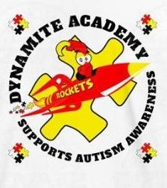
Puzzle piece coloring table
Merchandise for purchase
Concessions
Door prizes
Face Painting
**All proceeds will go towards our Rockets (Autism) Program**130 Scott Rd, Building 4, Waterbury, CT 06705, 203-419-0661

