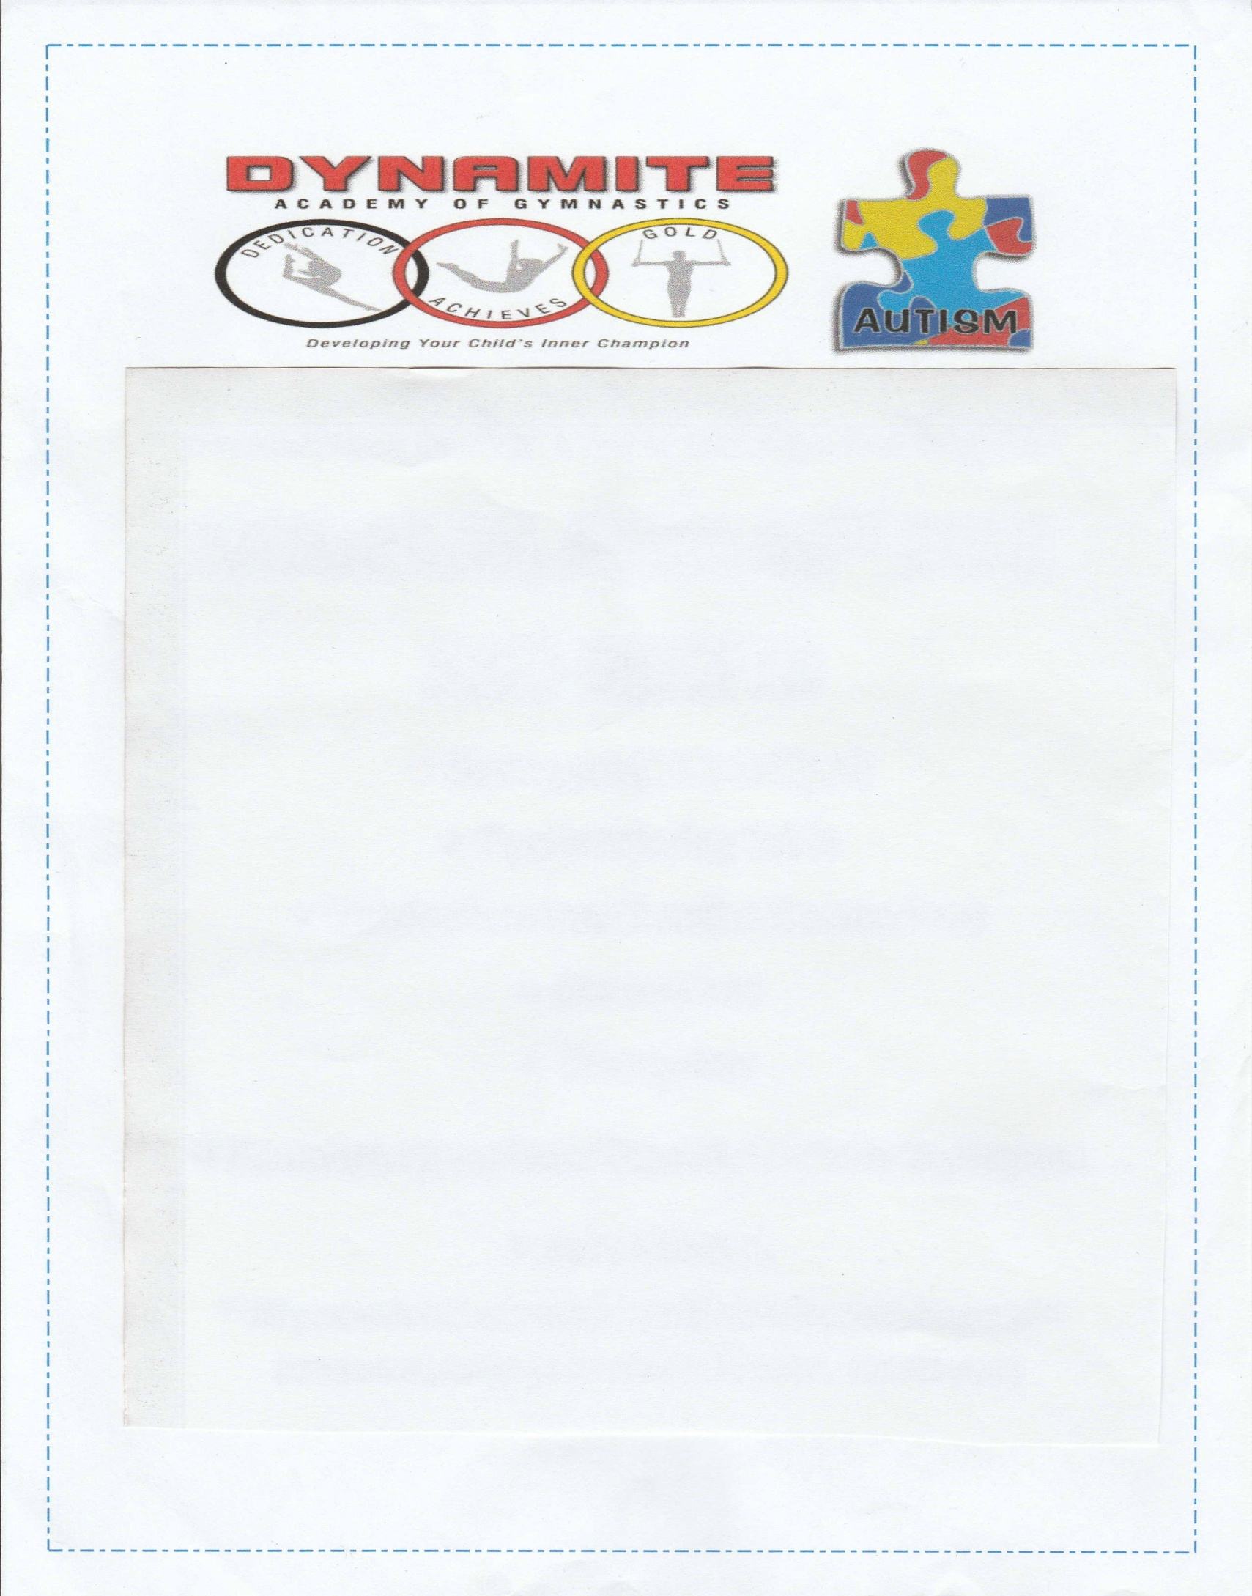
Dynamite Academy of Gymnastics
Rockets Program
Enter to Win a Free Session
Through generous donations and fund raising during the April 2015 DAG Autism Fair, we are pleased to offer a Rockets Program Session (8 weeks of classes), a $200 value,
To a child on the Autism Spectrum!

Please complete the information form attached and return to
Dynamite Academy of Gymnastics
By May 14, 2016.
Forms can be mailed, e-mailed, or dropped off

Drawing will be held on May 21, 2016 during our annual DAG Autism Fair.

REQUIREMENTS AND IMPORTANT INFORMATION FOR DRAWING
- New students only. Current students not eligible.
- Child must be between the ages of 4 and 16 years old
- The raffle includes the cost of the 8 week session ONLY. At the start of the session, a $30 yearly membership fee must be paid by the recipient/family.
- Class will be a 1:1 ratio.
- Student information sheet and waiver must be signed before first class.
- Evaluation session must be scheduled with instructor before start of session.
- Free session must be scheduled during Session 1 (August 27, 2016 to October 21, 2016) or Session 2 (October 22, 2016 to December 16, 2016).
- Class day and time to be scheduled between instructor and child’s parent/caregiver.

130 Scott Road Building 4, Waterbury, CT 06705 203-419-0661 dynamiteacademyofgymnastics@gmail.com

Dynamite Academy of Gymnastics
Rockets Program
Enter to Win a Free 8 Week Session

The information asked for below is for the sole purpose of providing the best match between student and instructor. All information is confidential and will not be used for any other reason.

Name of child: _______________________________________________ Age:_________________________
Child’s Date of Birth __________________________________________ Gender of Child M / F
Name of Parent/Guardian____________________________________________________________________
Address___________________________________________________________________________________
Phone Number_____________________________________________________________________________
Email Address______________________________________________________________________________
What is the child’s specific diagnosis? ___________________________________________________________
How does the child communicate? Circle all that apply
Verbal Non-Verbal Sign Language Picture Exchange Gestures Behavior Ipad/Iphone
Does the child have any physical limitations? Yes No
If yes, please explain: ______________________________________________________________________
_________________________________________________________________________________________
Does the child exhibit any aggressive behaviors, i.e. hitting, biting, throwing objects, etc.? Yes No
If yes, please explain: ________________________________________________________________________
__________________________________________________________________________________________
Does the child have any other behavioral concerns, i.e. self-stimming, OCD, running away, etc.? Yes No
If yes, please explain: ________________________________________________________________________
__________________________________________________________________________________________
Please return to Dynamite Academy of Gymnastics by May 14, 2016.
Forms can be mailed, e-mailed, or dropped off
Drawing will be held on May 21, 2016 during our annual DAG Autism Fair.
Winner will be contacted by phone.
130 Scott Road Building 4, Waterbury, CT 06705 203-419-0661 dynamiteacademyofgymnastics@gmail.com

