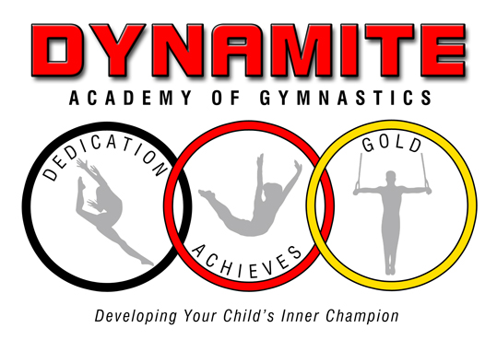
130 Scott Rd. Building 4 Waterbury, Ct. 06705
203-419-0661
www.DYNAMITEACADEMY.COM dynamiteacademyofgymnastics@gmail.com
Student Information
Student’s Last name:_________________________________________________
Please list child’s Name, Date of Birth & age of all children registering:
Child:__________________________Date of Birth:_______________Age:______
Child:__________________________Date of Birth:_______________Age:______
Child:__________________________Date of Birth:_______________Age:______
Address:___________________________________________________________
City:______________________________State:_________Zip Code:___________
Home Phone:____________________ Cell Phone: _________________________
Email address:_______________________________________________________
Parent/Guardian:_________________________Employer:__________________
Parent/Guardian:_________________________Employer:__________________
Does your Child have previous experience:_______________________________
Please provide additional contacts if parent can not be reached so we may act quickly in the event of emergency.
Name/Relation:_____________________________Phone:__________________
Name/Relation:_____________________________Phone:__________________
Doctor’s Name:_____________________________Phone:__________________
Medical Insurance company:___________________Policy:__________________
Any intolerance to Medications?________________________________________
Any previous illness or injury the staff should be aware of:__________________
If YES, are there any Restrctions?:_______________________________________
Is there any Disorder we should be aware of so we can make your child’s experience fulfilling and enriching, (IE, Neurological, MR, ADD/ADHD), this will help the instructor and the student:___________________________________
___________________________________________________________________

Date enrolled:_________________________Class Begins:___________________

Waiver Release

I fully understand that DYNAMITE ACADEMY OF GYMNASTICS’ STAFF members are not physicians or medical practitioners of any kind. With the above in mind, I hereby release DYNAMITEACADEMY OF GYMNASTICS’ STAFF to render temporary first aid to my child or children in the event of any injury or illness, and if deemed necessary by the Dynamite Academy of Gymnastics’ staff member and or its representatives, whether paid or volunteer, to any health care facility or hospital, or the calling of an ambulance for said child should the Dynamite Academy of Gymnastics’ Staff deem this to be necessary.

Parent/Guardian signature: ____________________________________ Date: ______________

We, the staff of DYNAMITE ACADEMY OF GYMNASTICS’ recognize our obligation to make our students and their parents aware of the risks and hazards associates with the sport of gymnastic, tumbling, trampoline and dance.

Students may suffer injuries, possible minor, serious, or catastrophic in nature. Gymnastics, trampoline, and tumbling can be dangerous and can lead to injury!

Parents should make their children aware of the possibility of injury and encourage their children to follow all safety rules and the coaches’ instructions. The DYNAMITE ACADEMY OF GYMNASTICS, it’s coaches and other staff members, do not accept responsibility for injuries sustained by any student during the course of gymnastics, tumbling, trampoline and dance instructions, open workout, open gyms, Birthday party participation, or in the course of any exhibition, competition, or clinic in which he/she may participate or while traveling to or from the event, other than injuries caused negligence or willful misconduct of the DYNAMITE ACADEMY OF GYMNASTICS, its coaches and other staff members.

With the above in mind, and being fully aware of the risks and possibility of injury involved, I consent to have my child or children participate in the program offered by DYNAMITE ACADEMY OF GYMNASTICS. I, my executors or other representatives, waive and release all rights and claims for damages that I or my child may have against the DYNAMITE ACADEMY OF GYMNASTICS and or its representatives whether paid or volunteer.

I also affirm that I now have and will continue to provide proper hospitalization, health and accident insurance coverage that is adequate for both my child’s protection and my own protection. I also understand that it is the parents’ responsibility to warn the child about the dangers of gymnastics and injury. DYNAMITE ACADEMY OF GYMNASTICS will only warn the child through “safety messages’ and our teaching style and progressions.

ACKOWLWDGED AND AGREED:

Parent/guardian’s signature: ________________________________________ Date:____________

