Wear Your Halloween Costumes!
Halloween Costumes are allowed to be worn Monday October 24th through Saturday October 29th

***Halloween Costumes are NOT to be worn Saturday October 22nd***
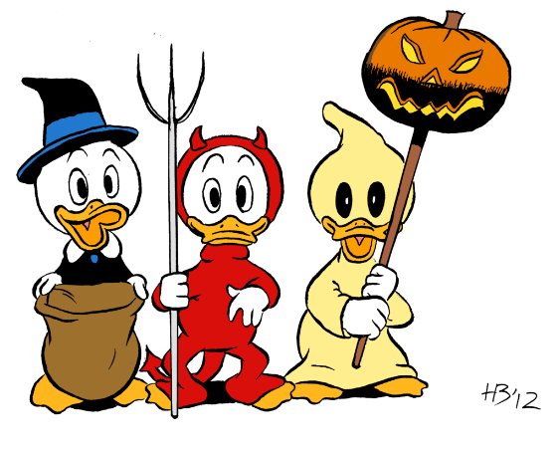
(No masks are to be worn and you must be able to move in the costume you choose to wear )

