**Session 3 Curriculum**

**Nov 30th– Jan 24th**

**(Weeks run Saturday to Friday)**



**WEEK 1**

All Events

Safety & Gym Rules

The children will learn how to land properly and how to fall forward or backward properly. We will also go over the gym’s safety rules!

**WEEK 4**

All Events Week

Basic event terminology

Vault: Run and Jump

Bars: Swing and Strength

Beam: Balance

Floor: Power and Grace

**WEEK 3**

**Holiday Week/Bounce Week**

Ski jump on DMT, bounce through snowman land, moguls down the mountain

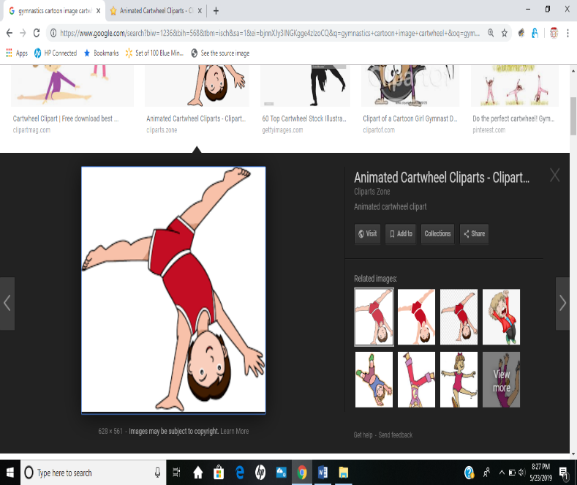

Week 5

Upside down Week

Bars, mini tramp, floor

We will help the children feel comfortable with being upside down.

**WEEK 6**

Review Week

Review of the different body positions, test locomotor skills, and different challenges on the equipment.