hj

**MONTHLY CLASS**

**TUITON FEE**

**SPARKLERS** (Parent & Tot: 3 -4 years old)

45 minute class $100.00/month

**FIRECRACKERS** (4.5 -6 years old)

45 minute class $100.00/month

**DYNAMITE: Boys/Girls** (6.5 – 8.5 years old)

45 minute class $100.00/month

**LITTLE DAGS** (9 – 11 years old)

45 minute class $100.00/month

**BIGS DAGS** (11.5 - 15 years old)

45 minute class $100.00/month

**TRAMPOLINE CLASS**

45 minute class $100.00/month

**BOYS FITNESS/T & T CLASS**

45 minute class $100.00/month

**ROCKETS FEES** (Special Needs)

1:1 (30 minutes): $100.00

**STUDENT/TEACHER RATIO:**

Sparklers: 6:1 Big Dags: 6:1

Firecrackers: 6:1 Trampoline: 6:1

Dynamite: 6:1 Boys Fitness: 6:1

Little Dags: 6:1

**PAYMENT POLICY:** Credit card auto pay only

**SPARKLERS CLASS**

This is a parent and tot program. During this class the parent assists the child with developing their locomotor skills, spatial awareness, listening skills, balance, and basic gymnastic skills. The parent, also, assists the child in overcoming their nervousness.

**FIRECRACKERS CLASS**

The goal of this program is to teach the children how to follow directions, interact appropriately with other children, and learn how to follow a circuit. Throughout the program the children will learn progressive gymnastic skill development on all events.

**DYNAMITE CLASS (boys/girls)**

In this program, the children improve their basic gymnastic skill development and begin the progressions for higher level skills on the events.

**LITTLE/BIG DAGS CLASS**

Girls will work on progressive gymnastic skill development on all events. The goal is to improve self-confidence, balance, coordination and overall fitness through the activity of gymnastics

**TRAMPOLINE**

Both girls and boys participate in learning trampoline safety, body control, spatial awareness, basic skills, combining multiple skills a routine format and all the joys of the sport

**BOYS FITNESS/TRAMPOLINE/TUMBLING CLASS**

This class is designed to assist boys in channeling their energy into a positive outlet. They will work on locomotor skills, coordination, strength and basic gymnastic skill development on floor and trampoline.

**ROCKETS PROGRAM**

This is a unique therapeutic gymnastics program for children with autism and other special needs. It incorporates sensory activities, social skills, language development and positive reinforcement while building self-esteem, flexibility, endurance and overall fitness. **All classes are 1:1.**

**COMPETITIVE TEAMS**

**Mission:** To develop the inner champion in each athlete

**Vision:**  To help each child aspire to the highest levels in Women’s Artistic Xcel Gymnastics program and the Trampoline and Tumbling program.

**Philosophy:** To teach each child to become strong, confident individuals who achieve their goals and overcome obstacles.

Our athletes compete locally, regionally and nationally.

**\*\*By Invitation Only\*\***

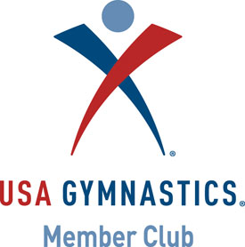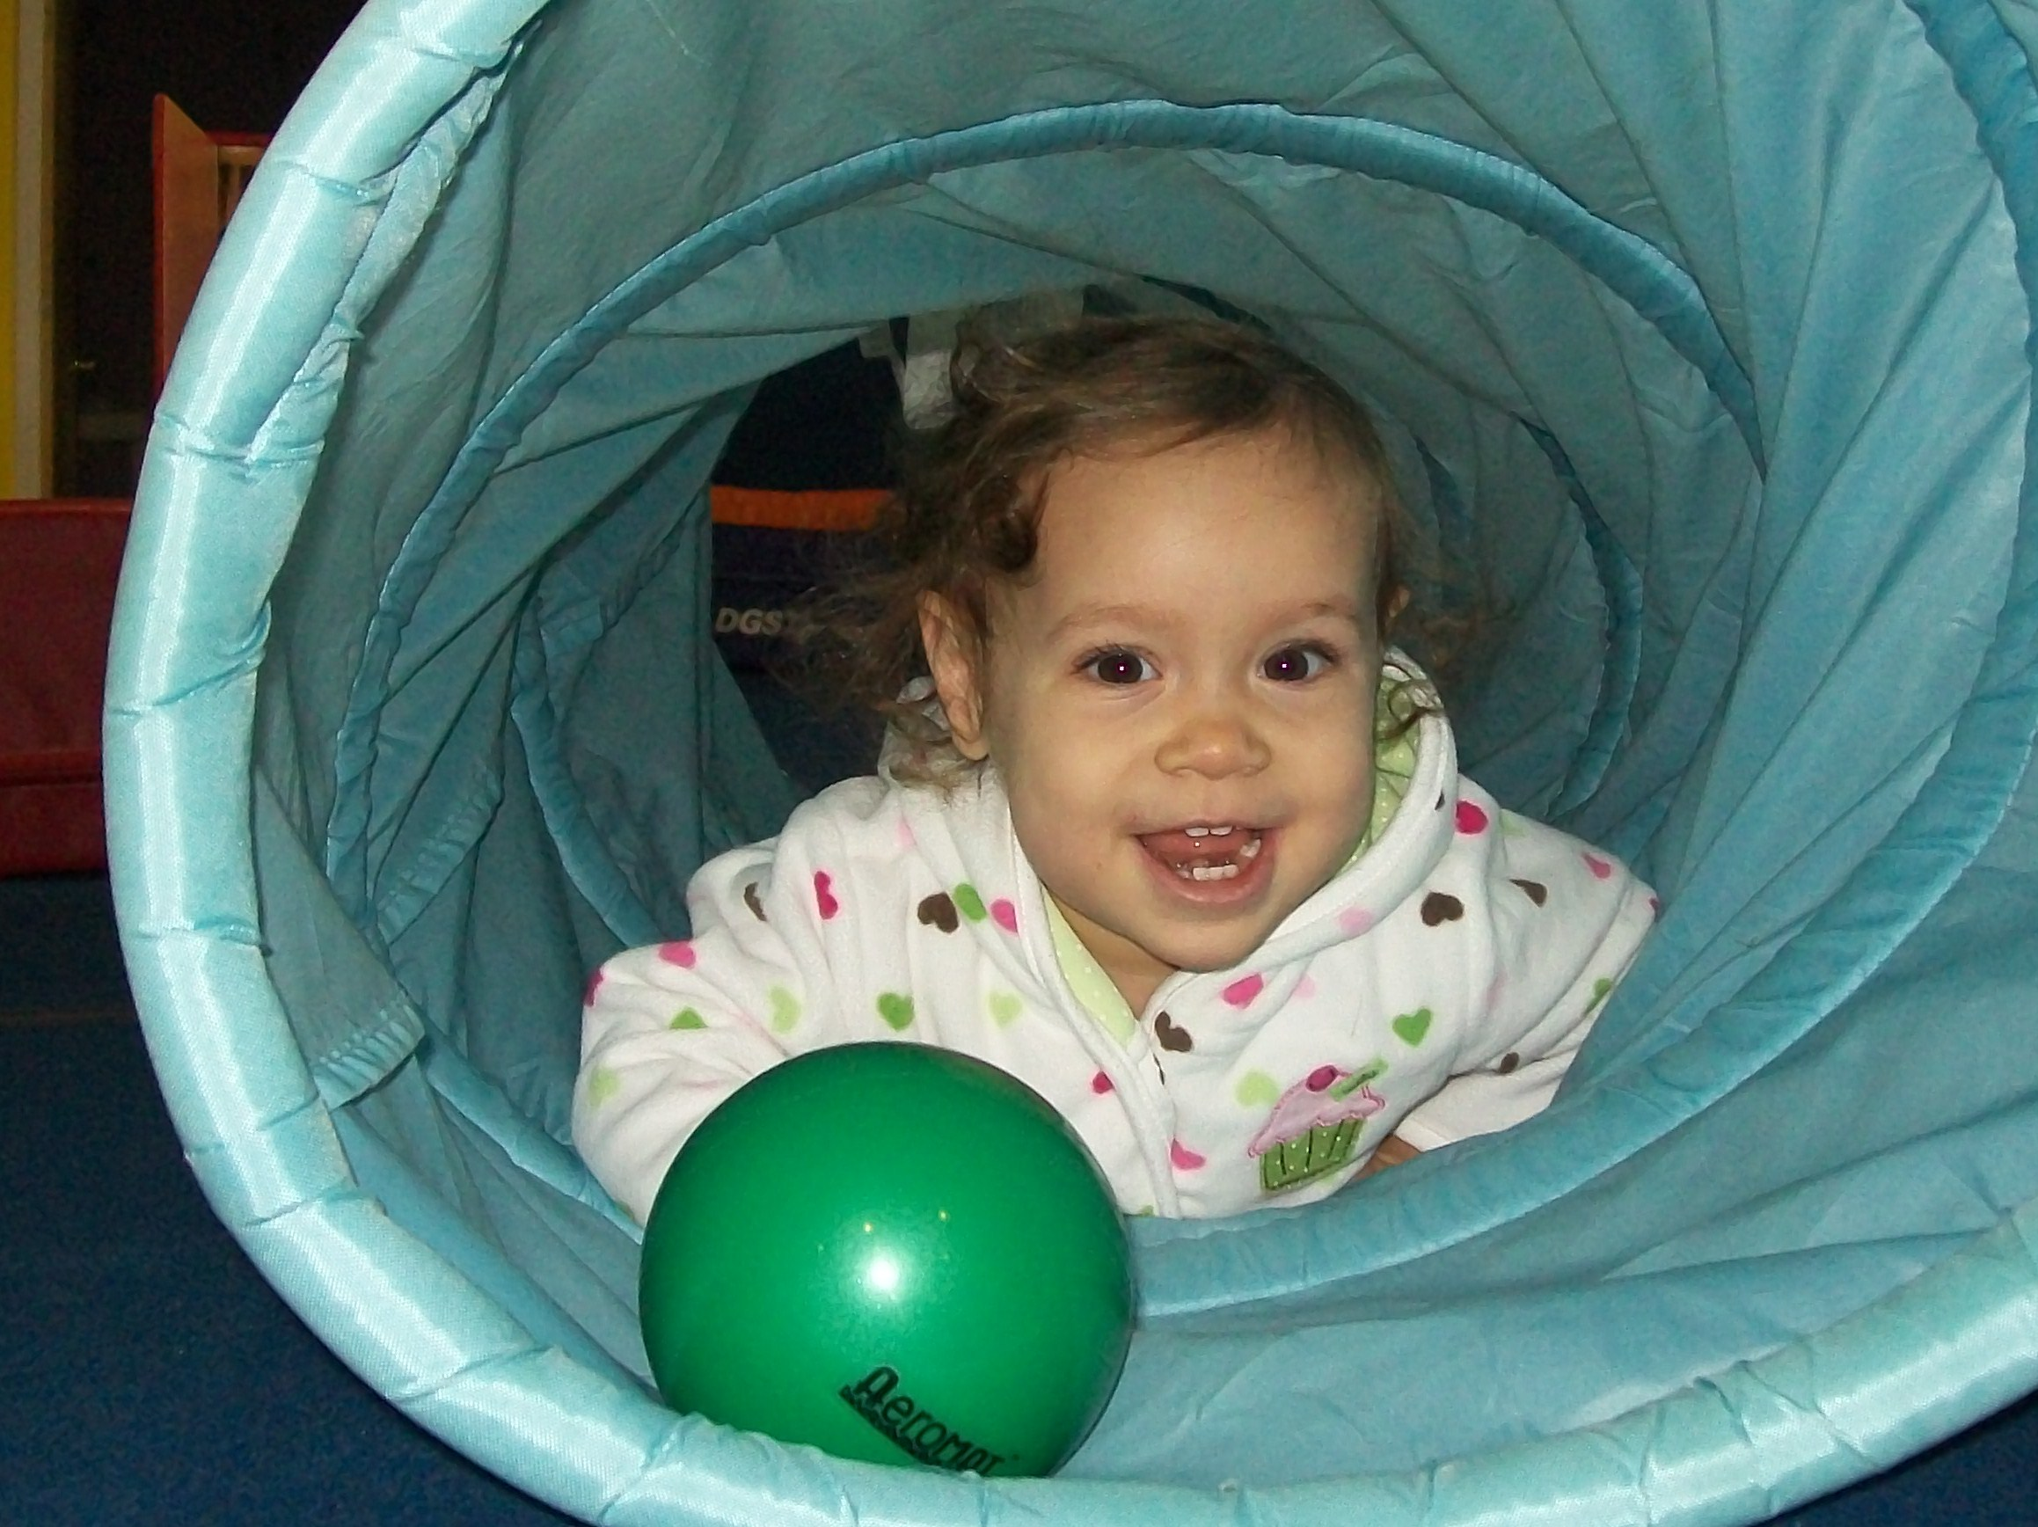Image_003dagotherlogodagotherlogo 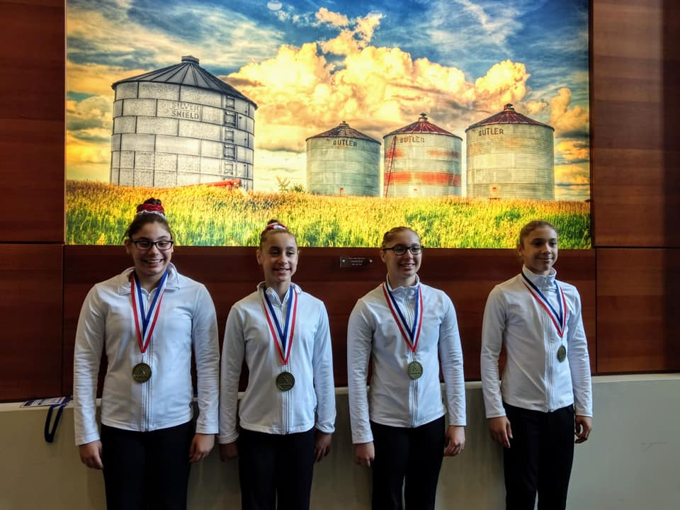

How often have you said, “I would love to see my child challenged, have fun, and grow to be a successful adult?” Now you can stop talking about it and do it! We make it easy to have the adventure of a lifetime with our expert gymnastics instructors, developmentally appropriate placement, challenging and fun lesson plans, a safe environment, and a positive and fun atmosphere. Yes, as a member now you can become part of DAG and have an adventure that will enhance your child’s development for a lifetime.

**Czarina age 6 months**

**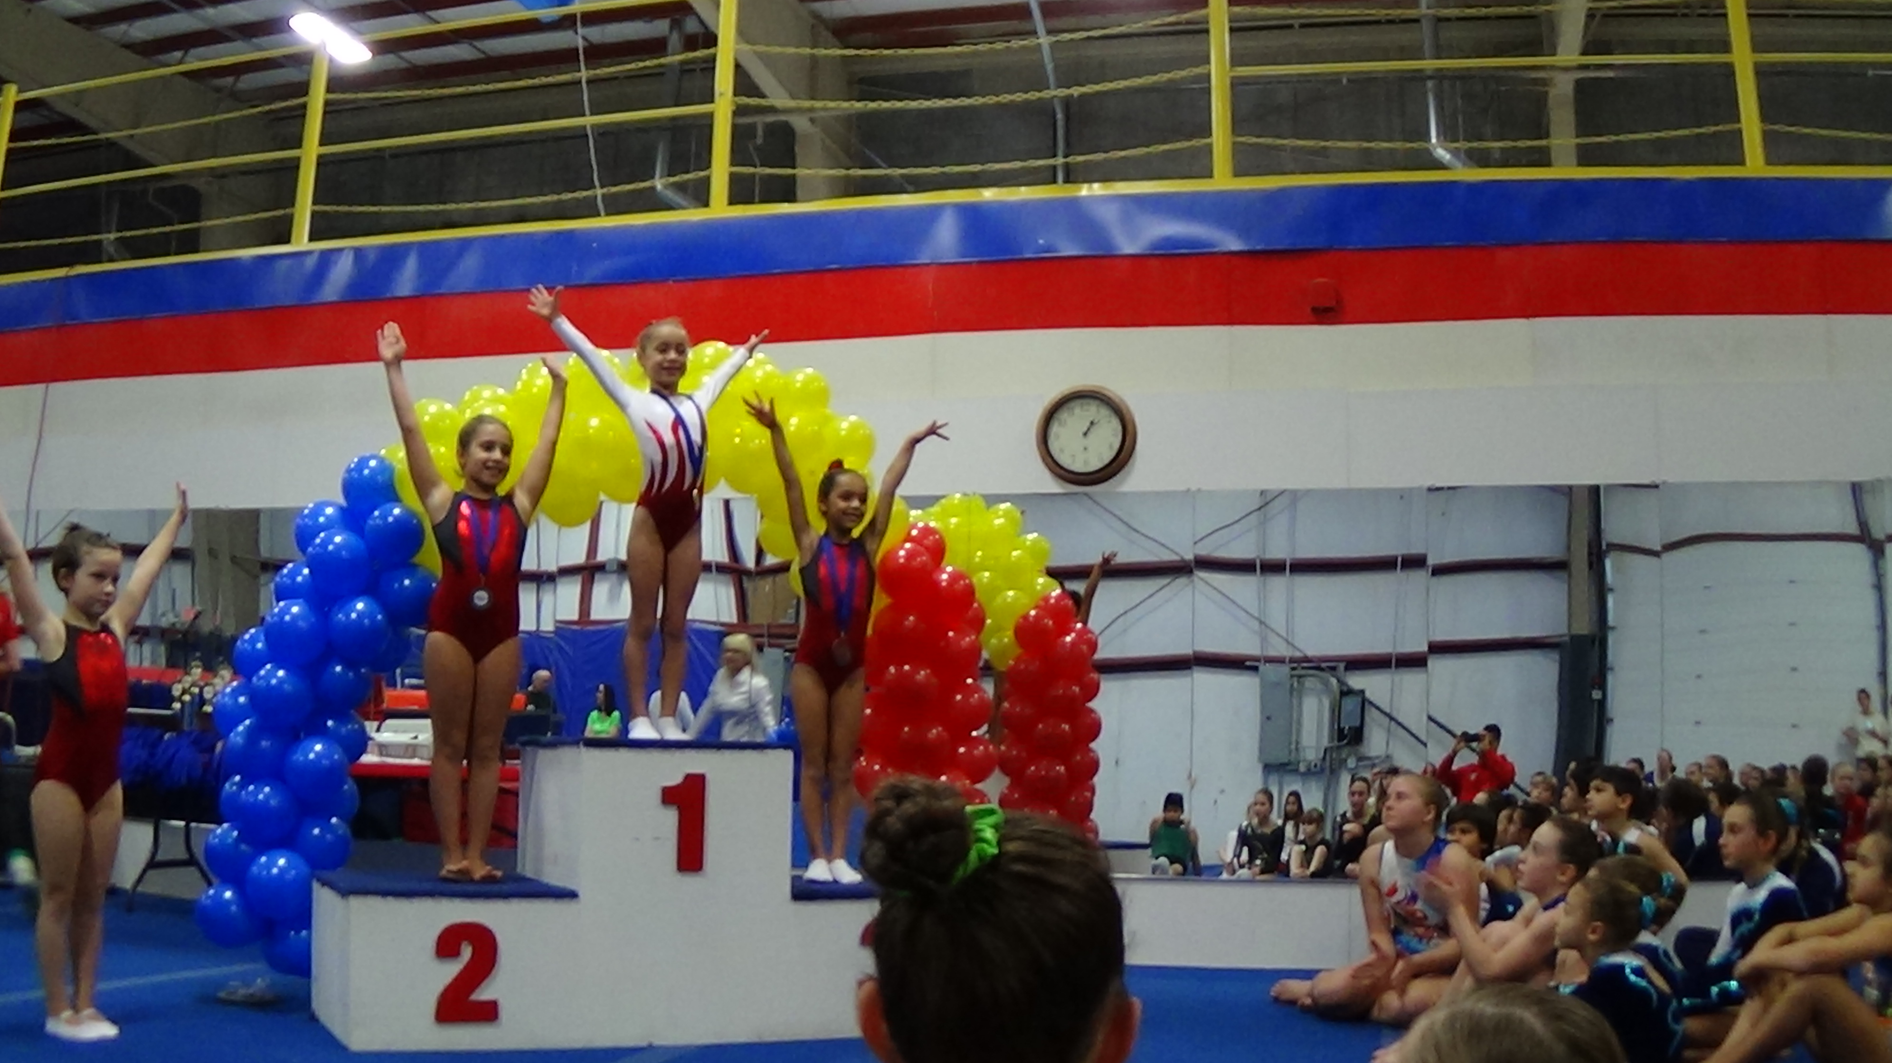**

**Czarina age 6 years**

**CONNECT WITH US ON**

Dynamite Academy of Gymnastics began in January 2001 in Waterbury, CT on the philosophy of bringing gymnastics to all children. As a family owned business, we know how important every aspect of a child’s life is to their development. We have worked hard to create a program that is fun, positive, and challenging to the children. At D.A.G., we believe every child is number one and wework with the family to help each student achieve their individual best.

**130 SCOTT ROAD BUILDING 4**

**WATERBURY CT 06705**

**203.419.0661**

[**WWW.DYNAMITEACADEMY.COM**](http://WWW.DYNAMITEACADEMY.COM)[**dynamiteacademyofgymnastics@gmail.com**](mailto:dynamiteacademyofgymnastics@gmail.com)

**The Rodriguez Children**

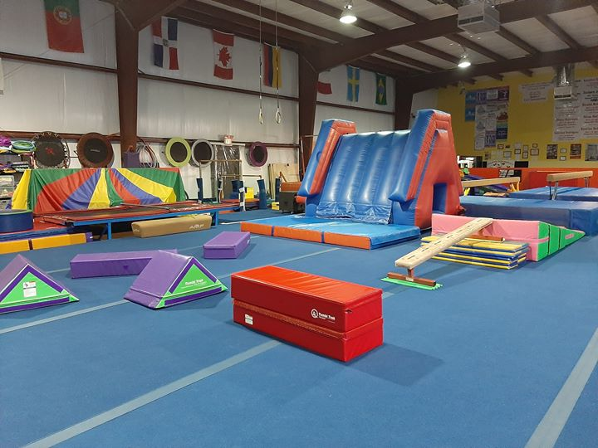 *2019 National Champions*