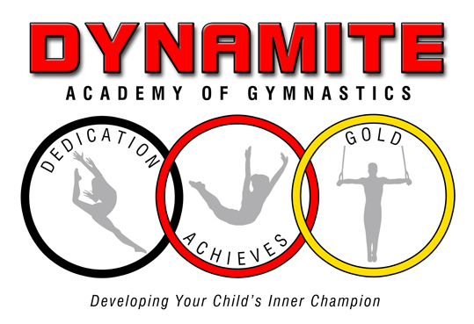
LOBBY RULES/POLICIES
We are asking that all customers follow these guidelines to ensure the safety of each other, the children, and staff.

- One adult per child in lobby. NO siblings.
- The parent/guardian/child must wear a mask over the nose and mouth in the lobby at all times.
- The Parents need to wait until the class ahead leaves the lobby before entering (approx. 15 minutes) to watch your child.
- Parents: Do not talk to or wave at your child. This can put the child at a risk of injury.
- Please maintain social distancing between each other, the lobby chairs are set up 6 feet apart.
- No Food or drink is permitted in the Lobby.
- One person in and out of the facility at a time. We have marked off waiting areas.
- There are no cubbies. The parent/guardian is responsible for the child’s clothing and shoes.
- Please email any questions to
dynamiteacademyofgymnastics@gmail.com or call
(203) 419-0661 between 6:00pm – 8:00pm
- Do not come in if you have a fever of 100.4 degrees, sore throat, nasal congestion, cough, nausea, headache or shortness of breath.
- COVID-19 Exposure policy: If you have tested positive for COVID-19, you can return to in person classes 5 days after symptoms appeared, have no fever for 24 hours without fever reducing medicine and have a doctor’s note releasing the child for activity. If you tested positive and have no symptoms, you can return to class 5 days after the date of the positive test. If you are exposed to someone, who tested positive for COVID-19, you are required to quarantine for 5 days. A credit for one class will be applied to your account.
- Please leave promptly, so we can disinfect and prepare for the next class.

CLASS POLICIES

- Class ratios:
Girls/Boys/Trampoline/ T & T: 6-1
Dynamite: 6-1
Firecrackers/Sparklers: 6-1
- The children are required to wear masks in the lobby, but are optional for class. They will disinfect their hands before and after class.
- Attire Policy:
a. Leotards, short sleeve t-shirt, tanks, capris, gym shorts, leggings or sweatpants. No jeans or pants with zippers or snaps.
b. Hair must be tied up. Avoid clips and beads in the hair. The beads will hurt the child’s head when rolling or can hit the child in the eye when bouncing.
C. No jewelry. Stud earrings are acceptable.
- The children should bring their own water bottle with water only in it to class. They will bring it onto the floor to hydrate during class.
- Effective July 1, 2022, masks during class time are optional. Masks are required in the lobby. The children will socially distance 6 feet apart as best possible during class.
- The teachers will wear masks.
- There will be stations and circuit training.
- We use Melaleuca and Truce. They are both organic cleaning products that has been approved by the CDC. It is non-harmful to children.
- Do not send the children if they have a fever of 100.4 degrees, nausea, runny nose, dry throat, cough, rash, or shortness of breath. If you show these symptoms also, please do not enter the facility.
- The equipment will be disinfected between classes.
- Parents: Do not talk to or wave at your children during class. This is a distraction and causes a risk of injury.
- NO MAKEUPS ALLOWED FOR MISSED CLASSES.
13. COVID-19 Exposure: If you have tested positive for COVID-19, you can return to in person classes 5 days after symptoms appeared and have no fever for 24 hours without fever reducing medicine. If you tested positive and have no symptoms, you can return to class 5 days after the date of the positive test. If you are exposed to someone, who tested positive for COVID-19, you are required to quarantine for 5 days. A credit for one class will be applied to your account.

Payment Policies
- Monthly tuition
- Automatic payments only
- No check/cash
- Must fill out credit card authorization form
- Notify us two weeks prior to the 1st of the month if you do not want your card charged.
- No makeups
- There are no sibling discounts
- No refunds after the 1st of the month.

PARENTAL ADVISORY AND ACKNOWLEDGEMENT

While Dynamite Academy of Gymnastics is working hard to follow the State Health Department and CDC guidelines to prevent the spread of COVID-19 virus, we cannot make any guarantees.
Our instructors and office team are symptom free and to the best of their knowledge have not been exposed to the virus. Since we are a public establishment, we are asking all parents/guardians to wear masks in the lobby to reduce the risk of spreading the virus.
I, parent/guardian of have read, understand and will follow all the guidelines and policies set down by Dynamite Academy of Gymnastics.
Parent/Guardian’s signature:

