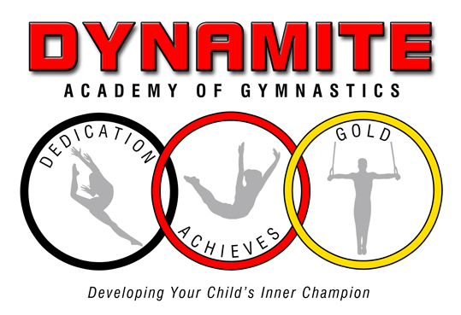

**LOBBY RULES/POLICIES**

We are asking that all customers follow these guidelines to ensure the safety of each other, the children, and staff.

1. **One adult** per child in the lobby.
2. No children permitted in the lobby except registered students
3. **Parents:**  Do not talk to or wave at your child. This can put the child at risk of injury.
4. **No** running, jumping, skipping or doing any form of gymnastics i.e. handstands, cartwheels, bridges in the lobby. This is for the safety of the children and the other customers.
5. Children are not to be left alone in the lobby to observe their siblings.
6. **Videotaping:** You are permitted to video tape your child behind the glass area of the lobby. Do not block the entrance or exit of the lobby. Please, video tape your child only**. If another child is in the video, do not post it on social media**.
7. Please be respectful of the other customers viewing their child. Do not move the chairs. They are placed at a respectful distance to allow each parent to feel comfortable while viewing their child.
8. **Cell Phone Usage Policy:** Out of Consideration for all parents and visitors, please be sure your phone is on silent or vibrate mode. If you need to take or make a call, we ask that you step outside of the lobby to do so.
9. **No Food or drink is permitted in the Lobby**
10. There are **no** cubbies. The parent/guardian is responsible for the child’s clothing and shoes.
11. Please email any questions to [dynamiteacademyofgymnastics@gmail.com](mailto:dynamiteacademyofgymnastics@gmail.com).
12. **Do not** come in if you have a fever of 100.4 degrees, sore throat, nasal congestion, cough, nausea, headache, or shortness of breath.
13. **COVID-19 Exposure policy:** If you have tested positive for COVID-19, you can return to in person classes 5 days after symptoms appear, have no fever for 24 hours without fever reducing medicine. If you tested positive and have no symptoms, you can return to class 5 days after the date of the positive test. If you are exposed to someone, who tested positive for COVID-19, you can attend class if you have tested negative and wear a mask.
14. Please leave promptly, so the next class can enter the facility.
15. Removal from the program: Please, do not yell or aggressively talk to any personnel or customer. If this occurs, we will remove your child from the program. It creates a negative environment and this violates our Safe Sport policies.



**CLASS POLICIES**

1. Class ratios:

Girls/Boys/Trampoline/ T & T: 6-1

Dynamite: 6-1

Firecrackers/Sparklers: 6-1

1. Masks are optional. The children will disinfect their hands before and after class.
2. **DRESS CODE:**

a. Leotards, short sleeve t-shirt, tanks, capris, gym shorts, leggings, or sweatpants**. No jeans or pants with zippers or snaps.** The clothing should fit properly since the children will be rolling, jumping, squatting among many more activities

**b.** Hair must be tied up. **NO Beads** in the hair. The beads will hurt the child’s head when rolling or can hit the child in the eye when bouncing.

**C.** No jewelry. Stud earrings are acceptable.

1. The children should bring their own water bottle with water only in it to class. They will bring it onto the floor to hydrate during class.
2. The teachers wear masks to keep themselves healthy. It is a safety precaution, so we do not have to shut down. We are a family business with a limited staff.
3. There will be stations and circuit training.
4. We use **Melaleuca**. They are both organic cleaning products that have been approved by the CDC. It is not harmful to children.
5. **Do not** send the children if they have a fever of 100.4 degrees, nausea, runny nose, cough, rash, or shortness of breath. If you show these symptoms also, please do not enter the facility.
6. The equipment will be disinfected at the end of the day.
7. **Parents:** Do not talk to or wave at your children during class. This is a distraction and causes a risk of injury.
8. **NO MAKEUPS ALLOWED FOR MISSED CLASSES.**

**13. COVID-19 Exposure:** If you have tested positive for COVID-19, you can return to in person classes 5 days after symptoms appear and have no fever for 24 hours without fever reducing medicine. If you tested positive and have no symptoms, you can return to class 5 days after the date of the positive test. If you are exposed to someone who tested positive for COVID-19, you can attend class as long as you have no symptoms and test negative. You are required to wear a mask.



**Payment Policies**

* Monthly tuition will be charged on the 20th of the month prior to participating in the class to hold your spot.
* If payment is not received by the 25th of the month, you will lose your spot.
* Automatic payments only
* No check/cash
* Must fill out credit card authorization form
* Notify us by the 15th of the month prior to the next billing date. If you do not notify us by this date, your card will be charged the monthly class fee.
* No makeups
* There are no sibling discounts
* **No refunds after the 25th of the month**.
* **Declined payments will be assessed a $3.00 reprocessing fee**.



**PARENTAL ADVISORY AND ACKNOWLEDGEMENT**

While Dynamite Academy of Gymnastics is working hard to follow the State Health Department and CDC guidelines to prevent the spread of COVID-19 virus and other illnesses, we cannot make any guarantees.

Our instructors and office team are symptom free and continue to wear masks. Since we are a private business, we reserve the right to institute a mask mandate if the numbers of COVID-19 are high.

I, parent/guardian of have read, understand and will follow **all** **the guidelines and policies** of Dynamite Academy of Gymnastics.

Parent/Guardian’s signature: