SPARKLERS CLASS
This is a parent and tot program. The parent assists the child with developing their locomotor skills, spatial awareness, listening skills, balance, and basic gymnastic skills.
FIRECRACKERS CLASS
The goal of this program is to teach the children how to follow directions, learn progressive gymnastic skill development on all events and proper social skills.
DYNAMITE CLASS (boys/girls)
In this program, the children improve their basic gymnastic skill development and begin the progressions for higher level skills on the events.
LITTLE/BIG DAGS CLASS
Girls will work on progressive gymnastic skill development on all events. The goal is to improve self-confidence, balance, coordination, and overall fitness through the activity of gymnastics.
TRAMPOLINE
Both girls and boys participate in learning trampoline safety, body control, spatial awareness, basic skills, combining multiple skills a routine format and all the joys of the sport.
TUMBLING/TRAMPOLINE
In this class, the children will learn progressive tumbling skill development to advanced. They will also learn trampoline skill development and routine development.
BOYS FITNESS/TRAMPOLINE CLASS
This class is designed to assist boys in channeling their energy into a positive outlet. They will work on locomotor skills, coordination, strength and basic gymnastic skill development on floor and trampoline.
ROCKETS PROGRAM
This is a unique therapeutic gymnastics program for children with autism and other special needs. It incorporates sensory activities, social skills, language development and positive reinforcement while building self-esteem, flexibility, endurance and overall fitness. All classes are 1:1.

MONTHLY CLASS
TUITON FEE

SPARKLERS (Parent & Tot: 3 -4 years old)
45-minute class $110.00/month

FIRECRACKERS (4.5 -6 years old)
45-minute class $110.00/month

DYNAMITE: Boys/Girls (6.5 – 8.5 years old)
45-minute class $110.00/month

LITTLE DAGS (9 – 11 years old)
45-minute class $110.00/month

BIGS DAGS (11.5 - 15 years old)
45-minute class $110.00/month

TRAMPOLINE CLASS
45-minute class $110.00/month

BOYS FITNESS/T & T CLASS
45-minute class $110.00/month

ROCKETS FEES (Special Needs)
1:1 (30 minutes): $110.00

STUDENT/TEACHER RATIO:
Sparklers: 6:1 Big Dags: 6:1
Firecrackers: 6:1 Trampoline: 6:1
Dynamite: 6:1 Boys Fitness: 6:1
Little Dags: 6:1

PAYMENT POLICY: Credit card auto pay only
Payments are charged to the card on file on the 20th of the month prior to participating in class to hold your spot.
Must cancel 2 weeks prior to the end of the month.

COMPETITIVE TEAMS
Mission: To develop the inner champion in each athlete

Vision: To help each child aspire to the highest levels in Women’s Artistic Xcel Gymnastics program and the Trampoline and Tumbling program.

Philosophy: To teach each child to become strong, confident individuals who achieve their goals and overcome obstacles.
Our athletes compete locally, regionally and nationally.

**By Invitation Only**

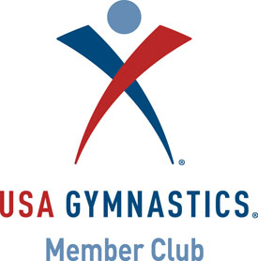
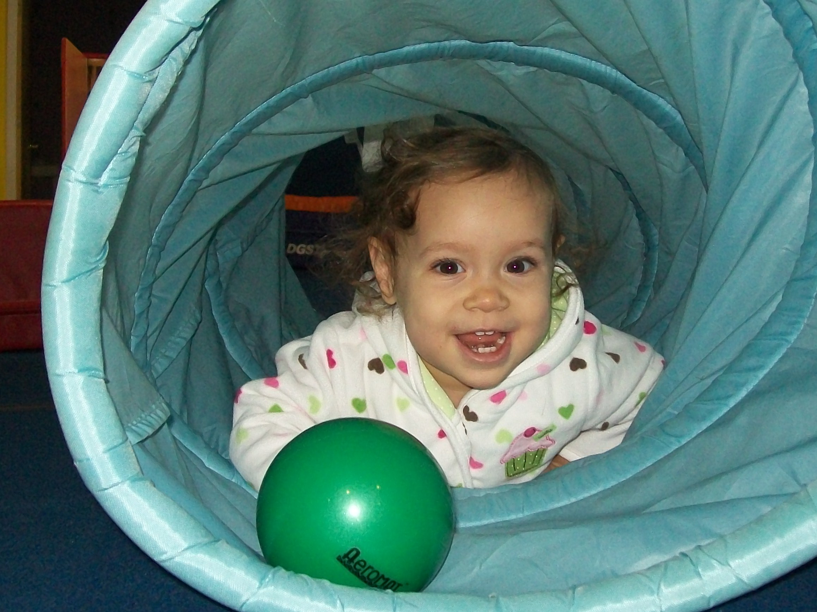
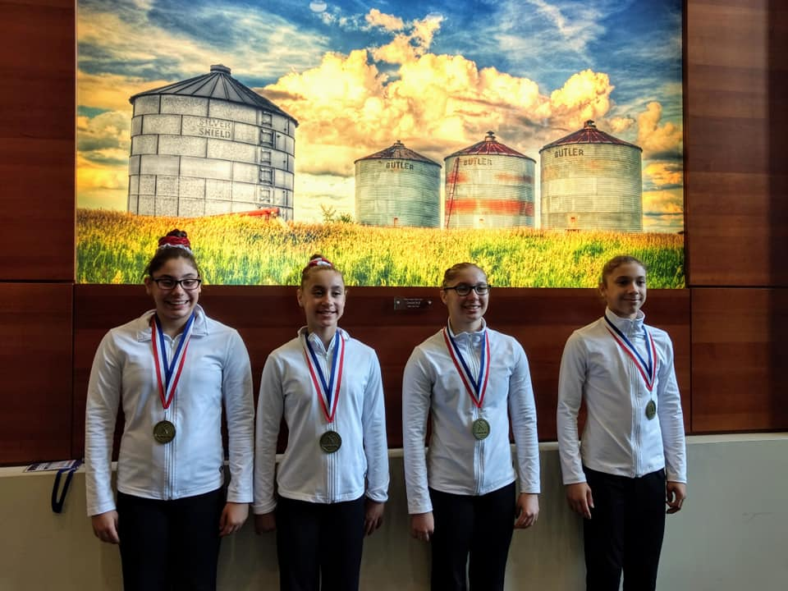
How often have you said, “I would love to see my child challenged, have fun, and grow to be a successful adult?” Now you can stop talking about it and do it! We make it easy to have the adventure of a lifetime with our expert gymnastics instructors, developmentally appropriate placement, challenging and fun lesson plans, a safe environment, and a positive and fun atmosphere. Yes, as a member now you can become part of DAG and have an adventure that will enhance your child’s development for a lifetime.
Czarina age 6 months

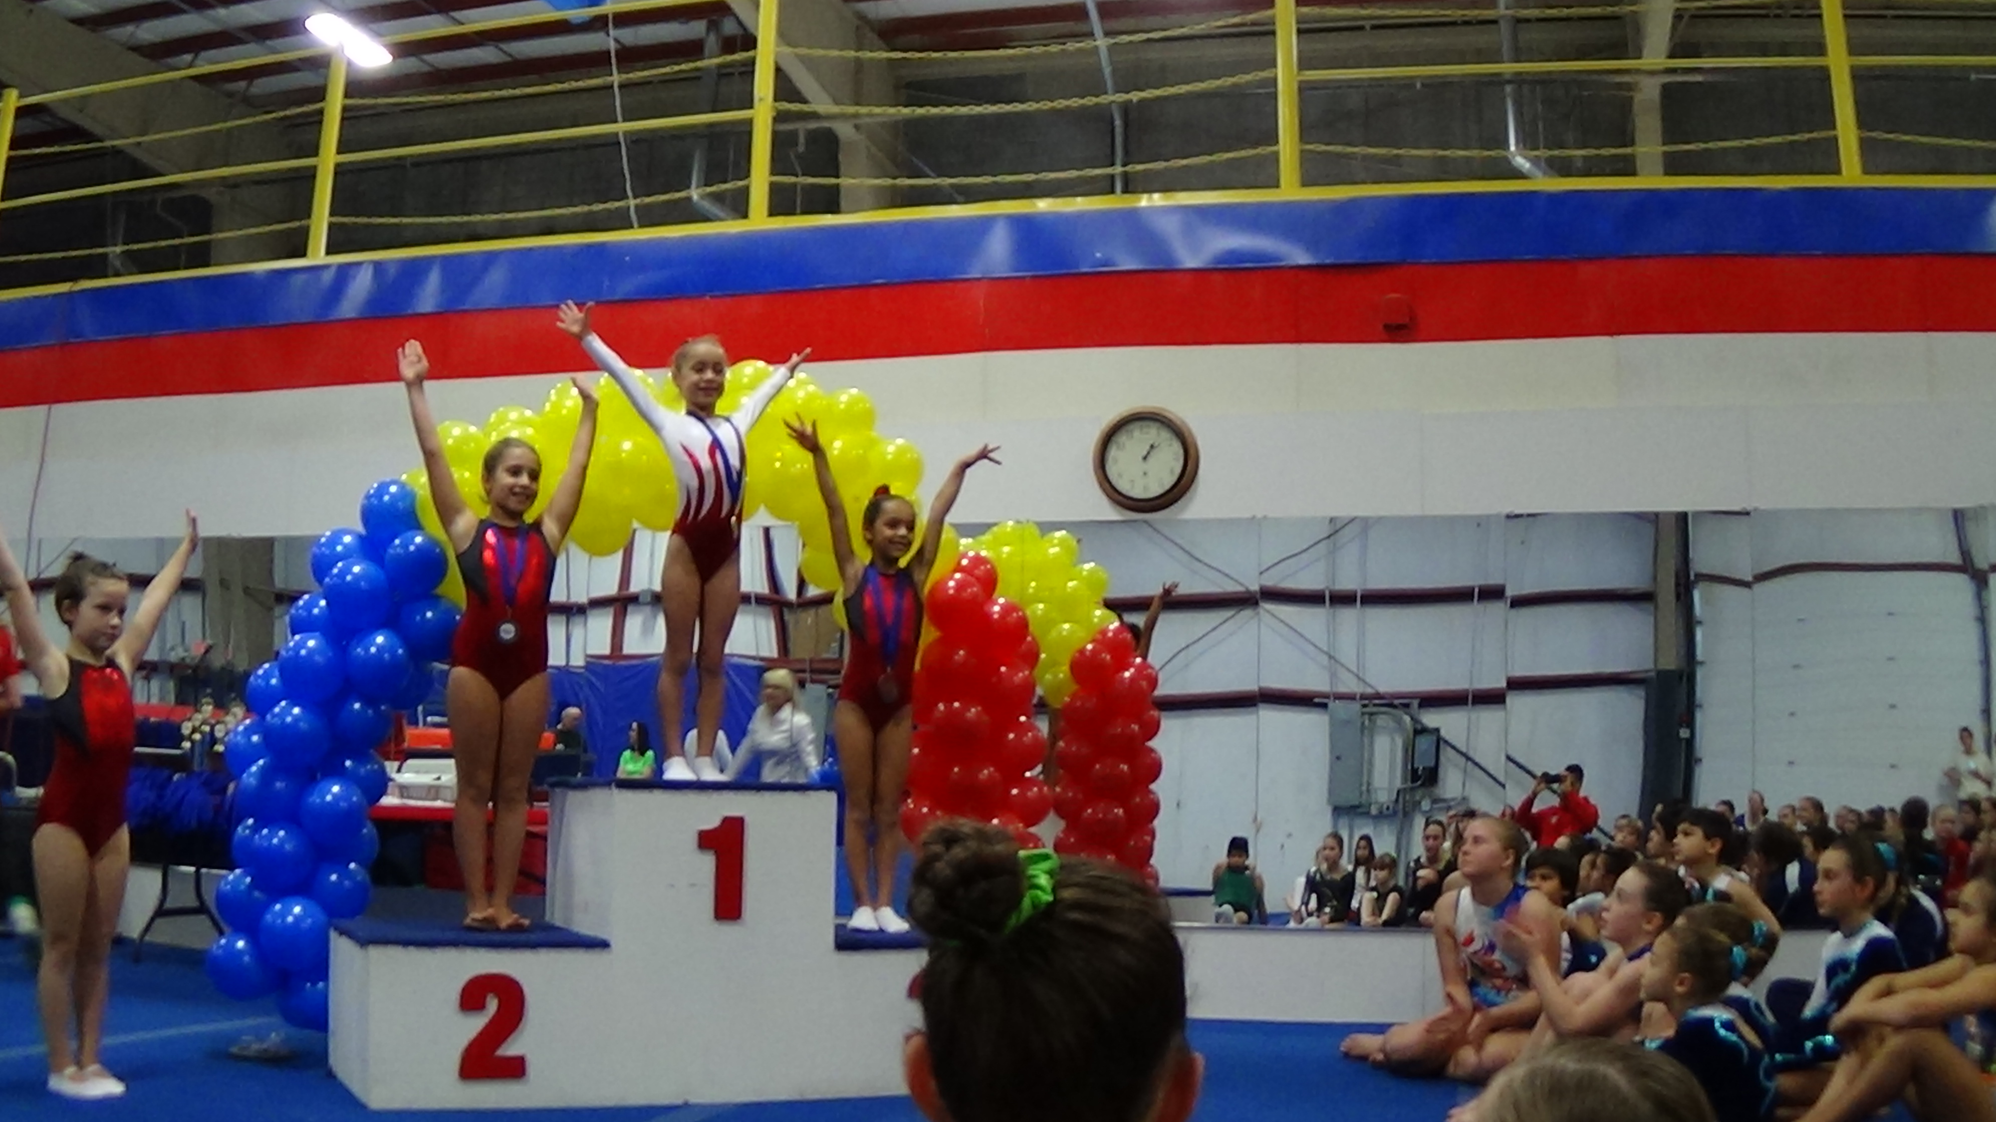
Czarina age 6 years

CONNECT WITH US ON

130 SCOTT ROAD BUILDING 4
WATERBURY CT 06705
203.419.0661
WWW.DYNAMITEACADEMY.COM dynamiteacademyofgymnastics@gmail.com

The Rodriguez Children
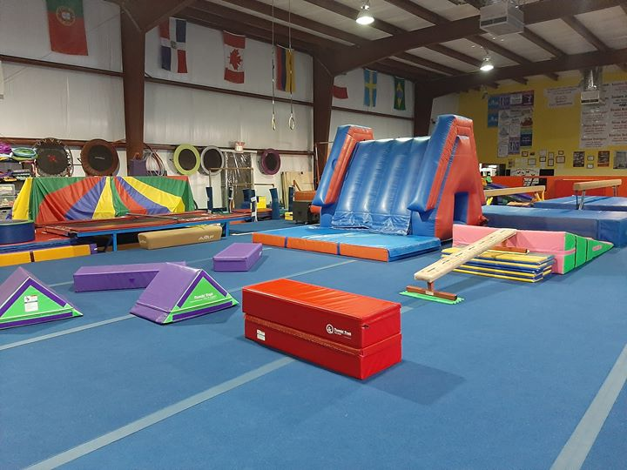
2019 National Champions
Dynamite Academy of Gymnastics began in January 2001 in Waterbury, CT on the philosophy of bringing gymnastics to all children. As a family owned business, we know how important every aspect of a child’s life is to their development. We have worked hard to create a program that is fun, positive, and challenging to the children. At D.A.G., we believe every child is number one and we work with the family to help each student achieve their individual best.

